

**National University of Computer and Emerging Sciences**

Software Engineering

**“Deliverable {1} – {Salon Management System}”**

**STUDENTS NAME and REGISTRATION NUMBERS:**

Hurriya Nasir 18I-0597

Zaynab Batool Reza 18I-0419

M. Adil Fayyaz 18I-0613

**DEGREE PROGRAM:** BS(CS)

**Section:** B

**SUBJECT NAME:** Software Engineering

**DATE OF SUBMISSION:** April 24, 2021

**SUBMITTED TO:**  Dr. Behjat Zuhaira

**STUDENT SIGNATURE:**

__**____________________________________________________________**

**MARKS:**

__**____________________________________________________________**

**REMARKS:**

__**____________________________________________________________**

**TEACHERS SIGNATURE:**

__**____________________________________________________________**

# Sprint Backlog for Sprint-1

## Name of Module

Appointment Booking Module

|  |  |  |  |
| --- | --- | --- | --- |
| Backlog ID | User Story | Value (Priority) | Time Estimate (Hours) |
| 0002 | As a customer I want to be able compare rates/services so that I can choose the most feasible option. | 3 | 19 |
| 0003 | As a customer I want to book an appointment so that I can save my time. | 1 | 18 |
| 0005 | As a salon owner I want to send out promotional notifications and show my available services so that I can market my business. | 2 | 13 |

## Sub User Stories for Sprint 1

1. Backlog ID: 0003
   1. As a customer I want to view the dates of my other booked appointments so that I can manage my schedule
   2. As a customer I want to book multiple services under one appointment so that I don’t have to book multiple appointments
   3. As a customer I want to view my cart and total cost of services as I select them so that I can anticipate how much it will cost and delete a service if needed
2. Backlog ID: 0005
   1. As a salon owner I want to login in order to manage my Salons so that no one unauthorized person has access to it.
   2. As a salon owner, I want to register multiple Salons under my name so that I can manage them efficiently.
   3. As a salon owner I want to add, delete and update services so that customers can see the latest information
   4. As a salon owner I want customers to be notified when I add a new deal to my Salon so that they can avail it in time.
3. Backlog ID: 0002
   1. As a customer I want to login to my account so that only I have access to my information and appointment bookings.
   2. As a customer I want all Salons to be listed on my dashboard so that I can easily select whose services I want to view.
   3. As a customer I want to view all available services of each Salon along with their prices so that I can decide which one to opt for.

## Tasks for User Stories

1. Backlog ID: 0003
   1. Generate an interactive Calendar
   2. Display all items in cart dynamically
   3. Generate an interactive Clock
   4. Add constraint for appointment timings
   5. Save appointment information to database
   6. Initialize calendar with previous appointment by same customer
   7. Make the list of Services interactive such that clicking on them adds them to cart
2. Backlog ID: 0005
   1. Design Salon Owner UI
   2. Allow Salon Owner to Sign Up and Add Salon
   3. Implement Login functionality for Salon Owner
   4. Allow Salon Owner CRUD Operations for Services
   5. Allow Salon Owner Add and Delete Operations for Deals
   6. Whenever a new Deal is added by Salon Owner, add it as a notification visible to customer
3. Backlog ID: 0002
   1. UI Design for the app
   2. Implement Sign Up functionality for customer
   3. Implement Login functionality for customer
   4. Access database to get list of services offered by each Salon
   5. Display interactive list of Salons to customer
   6. On selecting a Salon, display all Services offered by it

# Screenshots of Trello Board

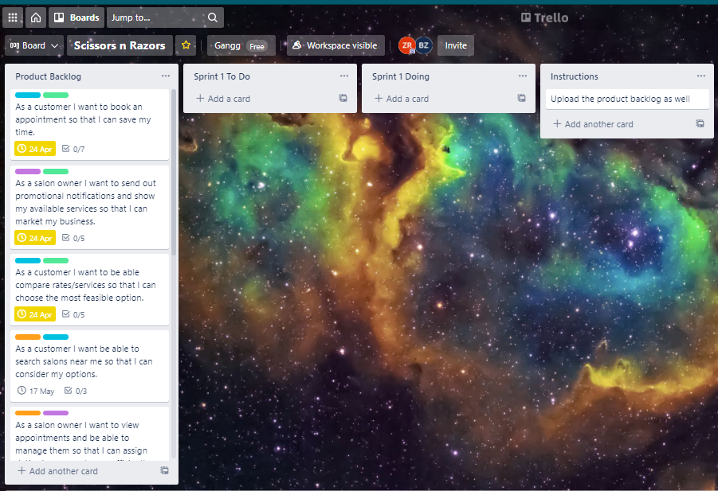

Screenshot-1

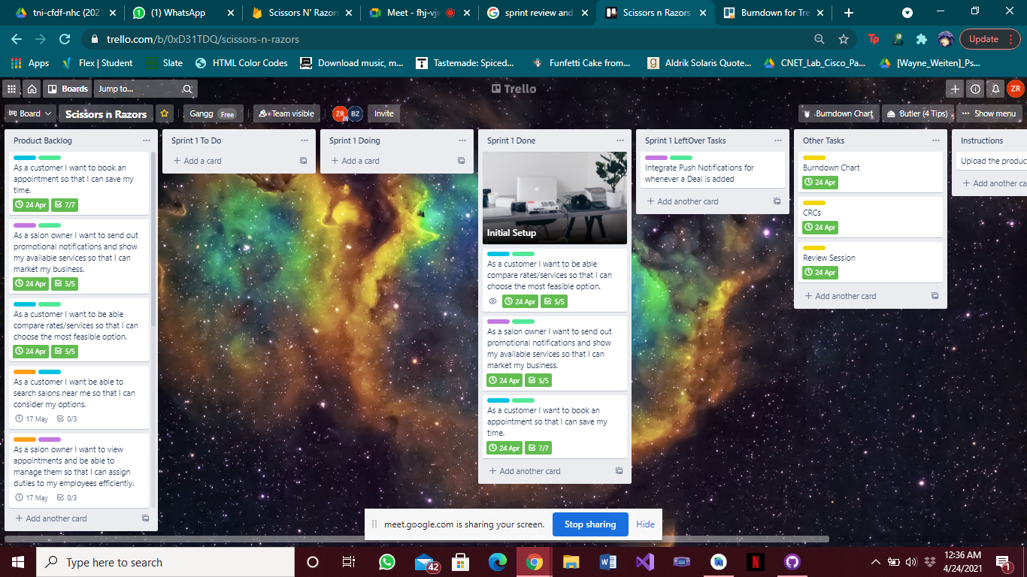

Screenshot-3

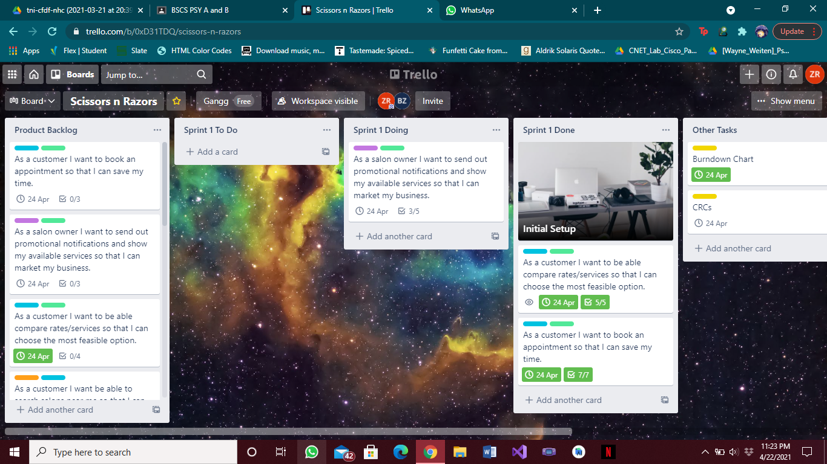

Screenshot-2

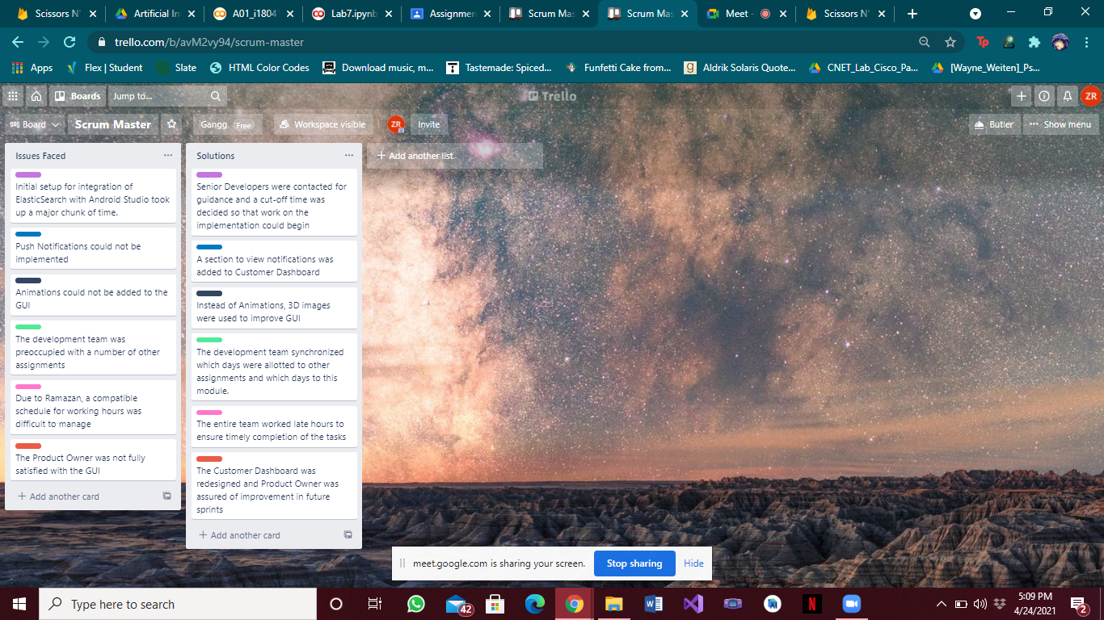

Scrum Master Board

# Class Responsibility Cards

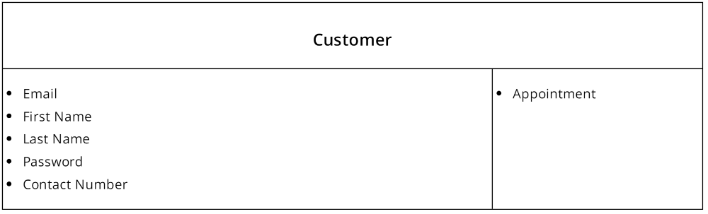

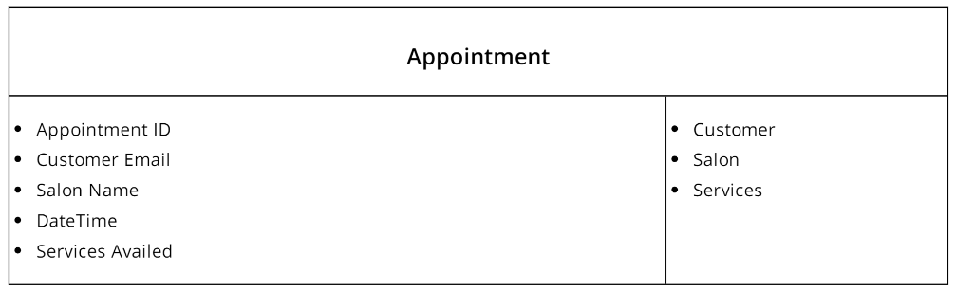

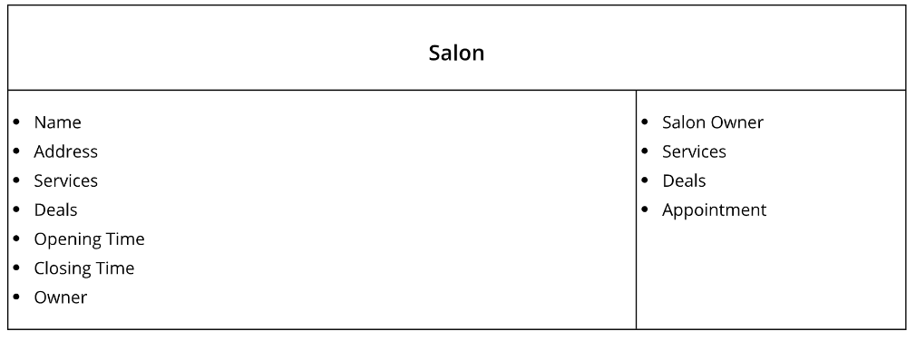

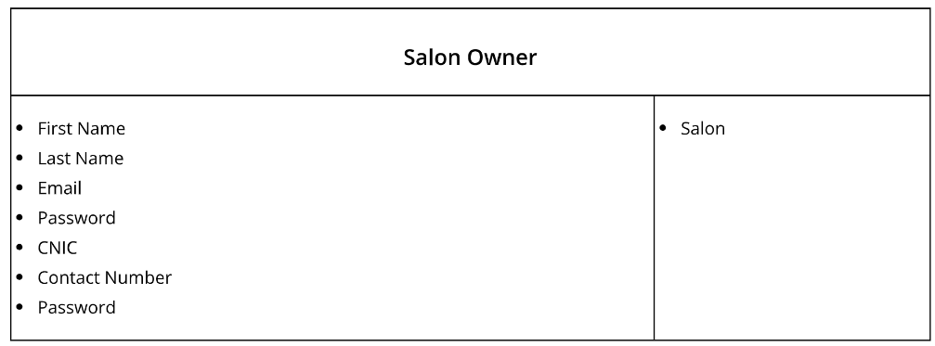

# 

# Burn Down Chart

